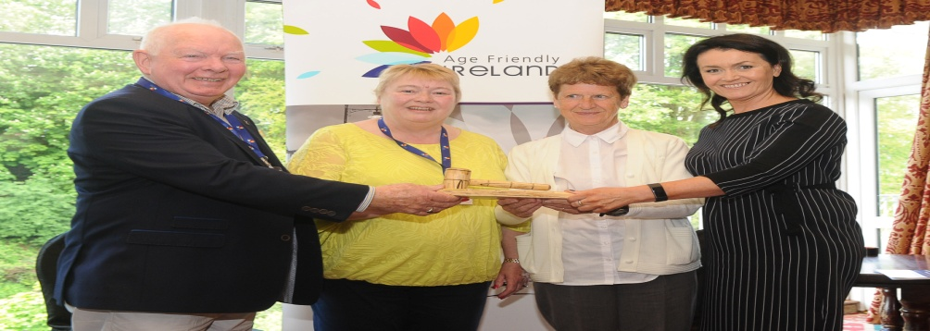
Older Persons Convention 2019

Donegal Age Friendly Alliance invited guests to the launch of their 2nd Age Friendly Strategy on May 9th in the Central Hotel by Cathaoirleach Cllr Seamus O’Domhnaill.
Seamus Neely Chief Executive of Donegal County Council and Chair of Donegal Age Friendly Alliance welcomed everyone attending the launch of Donegal’s 2nd Age Friendly Strategy. Mr Neely went on to explain the first strategy that was launched in 2015, contained 21 actions, and in implementing those actions, the Alliance, made up of organizations whose work has an impact on older people, has implemented practical projects that have had a positive impact on the lives of older people, and allows them to remain active members of their own community. Among the highlights over the past few years has been the Council’s social participation project Donegal’s Choir of Ages “Ceol le Chéile”, age friendly public spaces, improving provision of public transport, the establishment of the Older Persons Council and an audit of Letterkenny University Hospital which in turn has resulted in it becoming more age friendly.
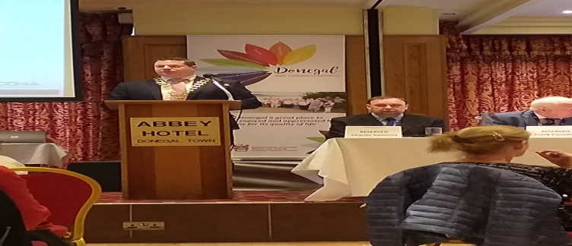
Mr Neely was delighted to announce that the new strategy contains 73 actions across the eight World Health Organisation themes and that Donegal County Council have begun implementing these actions with two very successful walkability audits being carried out in Dungloe and in Donegal Town.
Moya Brennan, lead singer of Clannad spoke about the traditions Donegal people have and the importance of these being passed on to the youth. Moya mentioned that she is always on the road working and living away from home but loves coming home and shared some fond memories of her younger years growing up in Donegal. She continued to say that she was delighted to see such great work being done for the Older Generation in Donegal and she will continue to support the Age Friendly programme for her own future coming home to Donegal.
Ms Catherine McGuigan Chief Officer Age Friendly Ireland commended Donegal County Council and Donegal Age Friendly Alliance for the success in completing the term of their first age friendly strategy, that Age Friendly Ireland are delighted to say under the new shared services agreement that they will continue to support and provide technical guidance like they do for all Age Friendly Programmes for the implementation of the new Strategy.
Cathaoirleach Cllr Seamus O’Domhnaill spoke about since the establishment of the Age Friendly Alliance in 2014, Donegal County Council along with the other Age Friendly stakeholders have been working collaboratively to implement actions that meet our overall objective of making Donegal a better place in which to grow old and will continue to do so for the next three years. He continued to speak about the 73 Actions in the new Strategy and how proactive Donegal County Council are in having already started implementing them with the organising of the walkability audits which I was delighted to be a part of in Dungloe and Donegal Town. The numbers gathered for these two events proved to be the biggest walkability audits in Ireland, which goes to show the need and the impact of the Age Friendly Programme here in Donegal. Cllr O’Domhnaill officially launched the Donegal Age Friendly Strategy 2019 to 2021.
Copies of the Strategy will be available soon online or contact Mairead Cranley Tel: 074 9153900 Email mairead.cranley@donegalcoco.ie if you require a copy.

